Karuk Tribe Watershed Research Collaboration: A Pilot Study to Understand the Pesticide Impacts from Cannabis Cultivation within Karuk Aboriginal Territory (Surface Water and Sediments),
Nora Bartolomé Gutiérrez, Earl Crosby, Sibyl Diver, Susan Fricke, Michelle Hladik, and Grant Johnson
Executive Summary:
Given the intensification of cannabis as a newly authorized agricultural commodity crop in California and anticipated land use change, as well as the legacy of illicit cannabis cultivation, there is an urgent need for water and sediment monitoring programs to assess cannabis-related impacts to nearby watersheds. This includes evaluating downstream pesticide runoff from cannabis cultivation areas. To create effective water quality monitoring systems for cannabis-related pollution, we also need to fill current knowledge gaps about the pesticides being used by cannabis growers, as well as the potential public health and environmental impacts of cannabis cultivation.
Such research and monitoring is a high priority for the Karuk Tribe, given the risk of pesticide contamination for key water sources serving both tribal and non-tribal community members along the Klamath River. The Karuk Tribe a long history of residing in the mid-section of the Klamath River Basin in northern California. Both legal and illegal cannabis cultivation is occurring within Karuk Aboriginal Territory, a large and rural area comprising 1.38 million acres. In response to this challenge, the tribe has launched a collaborative pilot study to understand the impacts of cannabis cultivation to local water quality. This initiative is responding to insufficient information sharing by federal agencies regarding cannabis operations within Karuk territory. This work builds off the expertise of the Karuk Tribe’s Water Quality Program, and is consistent with the Karuk Tribe’s inherent responsibility for managing its cultural resources and promoting the well-being of its people.
The study occurred during the spring run off period in 2019. To assess potential pesticide contamination, a team of Karuk tribal water managers and university researchers tested for active pesticide ingredients and degradation products in both surface water and sediments at four different tributary sites along the Klamath River (i.e., Red Cap, Crawford, Dillon, and Elk creeks). These four sites were selected because of their importance as community drinking water sources and as cultural use areas for tribal members. They were also selected due to the presence of suspected or known cannabis operations in upstream areas. We used passive sampling methods for surface water testing, and active sampling methods for soil and sediment testing.
We analysed 184 chemicals in surface water including active pesticide ingredients and their potential degradation products. In total, we detected 12 different compounds at levels above their analytical reporting limits (1 ng/sampler): 4 insecticides, 3 herbicides, and 5 metabolites. Results gathered from passive sampling methods only indicated the presence or absence of the selected target compounds, and did not provide concentration ranges. For this reason, we cannot draw conclusions about the toxicity levels of the detected chemicals from surface water measurements. Among the four tributaries sites tested in our pilot study, we detected the highest number of compounds at Crawford Creek, which provides the water supply for about thirty homes (with eight compounds detected in surface water and four compounds detected in sediment samples).
From the 84 pesticide related compounds analyzed in sediment samples, we detected 5 different pesticides and metabolites at levels above quantification limits (i.e, deltamethrin, fenpropathrin, fipronil sulfone, pentachloronitrobenzene, and propiconazole). Some toxicity value comparisons were possible from sediment samples, which we compared to known references for (a) lethal concentrations (LC50), and (b) lowest observed effect concentrations (LOEC). Low levels below LC50 were detected for the three compounds for which LC50 reference values were available in the published literature (deltamethrin, fenpropathrinm and fipronil sulfone).
The pesticide found at the highest levels in sediment was deltamethrin, a pyrethroid insecticide. We observed deltamethrin concentrations of 3.2, 6.5, and 1.7 ng/g at Red Cap Creek, Crawford Creek, and Dillon Creek, respectively. Toxicity levels for deltamethrin were consistently below LC50 levels (0.6 - 1.02 µg/g_{OC}). Toxicity levels for deltamethrin at Crawford and Dillon Creek were also below LOEC levels for the aquatic organism H. Azteca (0.2 µg/g_{OC}). However, deltamethrin toxicity levels in Red Cap were in the range of LOEC. This suggests that deltamethrin may negatively impact populations of amphipods and disrupt ecosystem balance at the Red Cap location. However, it is important to note that toxicity levels observed for deltamethrin do not currently raise concerns for human health impacts.
In summary, we detected the presence of 15 distinct pesticides and pesticide-related compounds that can be primarily linked to agricultural uses in key drinking water sources (Crawford and Elk creeks) for the Karuk Tribe and all local residents. At the same time, the compounds detected represent a small fraction of the pesticides that were tested for, and sediment concentrations were generally low compared to known toxicity reference values. The Karuk Department of Natural Resources is currently conducting follow-up monitoring at the four sites investigated in this initial pilot study.
Considering broader implications for research and policy, our findings suggest the need for expanding the array of pesticides being tested for in Karuk Territory. This should include rodenticides that have been previously identified in animal tissue samples in nearby Klamath Basin areas. Study outcomes further suggest the importance of establishing a meaningful baseline for pesticide loads in Karuk waters, before additional changes to land use and water quality occur. Finally, additional access to locational information regarding known cannabis cultivation sites would significantly aid current water quality monitoring and research efforts.

Introduction
For this project, the Karuk Tribe Department of Natural Resources, Stanford University, and the U.S, Geological Survey formed a research team to conduct a pilot study to understand the pesticide impacts from cannabis cultivation within Karuk Aboriginal Territory (surface water and sediments).

Project team members are:
- Earl Crosby, Watershed Restoration Coordinator, Karuk Dept. of Natural Resources
- Susan Fricke, Water Quality Program Manager, Karuk Dept. of Natural Resources
- Grant Johnson, Water Quality Project Manager, Karuk Dept. of Natural Resources
- Nora Bartolome, Organic Environmental Chemist and Visiting Scholar, Stanford University and Postdoctoral Researcher, Agroscope (Switzerland)
- Sibyl Diver, Research Scientist, Stanford University Department of Earth System Science
- Michelle Hladik, Research Chemist, U.S. Geological Survey

Introduction to the Karuk Tribe
The Karuk Tribe is the second largest tribe in California, with over 3,470 tribal members and 4,000 descendants. Since time immemorial, the Karuk people have lived in the Klamath-Siskiyou Mountains in the mid-Klamath River region of northern California (see Map in Appendix A). With an Aboriginal Territory that comprises an estimated 1.38 million acres, Karuk people historically resided in more than one hundred villages along the Klamath and Salmon Rivers and tributaries (Map in Appendix A). Given a thriving, subsistence-based economy supported by rich natural endowments and a strong culture-based commitment to land stewardship. Karuk environmental management practices have sustainably shaped the region’s ecological conditions for millennia, and continue to do so. Located about two hours drive from an urban area, subsistence practices continue to be important for many local residents.
Through carefully observing natural processes, the Karuk have developed traditional management regimes based on a landscape-level ecosystem approach. Self-described as "fix the world people”, the Karuk continue ceremonies that restore balance and renew the world. At the same time, the Karuk and the lands upon which they rely have been significantly disrupted since non-indigenous settlement in the region. This disruption includes the implementation of governmental policies of genocide, enslavement, ceremonial/spiritual criminalization, suppression of traditional management regimes, and removal of over 99% of aboriginal lands from exclusive Karuk management authority. Colonial legacies also include significant changes to the landscape arising from industrial scale resource extraction, such as mineral and timber use, in addition to the building of dams, water diversions and roads, agricultural development, land conversion, and wide scale herbicide treatments to facilitate industrial forestry production [1]. Despite these impacts, the Karuk continue to live in their aboriginal homeland and maintain a strong identity, culture, and connection to the natural environment.
In 1979, the United States federal government restored federal recognition of the Karuk Tribe as a sovereign tribal nation, which also established a government-to-government relationship with the United States. Shortly afterwards, the Karuk Tribe formally defined the boundaries of Karuk Aboriginal Territory, and developed the Karuk Tribal Constitution. Although federal recognition occurred without a conveyance of reservation and/or trust land, it did clearly establish the Karuk Tribe’s jurisdiction over its people, and the cultural resources that support them. Given the importance of reestablishing Karuk jurisdiction over its aboriginal territory, the Karuk Tribe is continuing its efforts to reacquire tribal land parcels, a process that began in 1977 with a 6.6-acre parcel in the municipality of Orleans. To date, the tribe has acquired land parcels totaling 1,660 acres in land area.

Karuk Tribe Department of Natural Resources
The Karuk Department of Natural Resources (DNR) is a department within the larger Karuk Tribe governance structure. In 1989, DNR was founded with a single employee after Congressional appropriations were allocated to support fisheries management and the restoration efforts of the Tribe. Since that time, DNR has seen exceptional growth, and is now a multi-program department includes over one hundred employees during fire events. All DNR staff share a common mission of protecting, promoting, and preserving the cultural/natural resources and ecological processes upon which the Karuk depend. A primary focus of the DNR is integrating traditional management practices into current land, water, and resource management. These traditional management practices are based on Karuk fix-the-world principles and philosophy, and are described in the Department’s Eco-Cultural Resources Management Plan (ECRMP):

As guardians of our ancestral land, we are obligated to support practices that emphasize the interrelationships between the cultural and biophysical dimensions of ecosystems. The relationships we have with the land are guided by our elaborate religious traditional foundation. For thousands of years, we have continued to perform religious observances that help ensure the appropriate relationship between people, plants, the land, and the spirit world. We share our existence with plants, animals, fish, insects, and the land and waters. We are responsible for their well-being. Our ancestral landscapes overflow with stories and expressions from the past, which remind us of who we are and direct us to implement sound traditional management practices in a traditional and contemporary context.

Karuk traditional management practices are coupled with Western scientific research, which includes data collection and analysis, to provide the contemporary management framework that DNR applies throughout Karuk ancestral homelands.

Karuk Tribe Department of Natural Resources Water Quality Program
Water quality and quantity issues are of the utmost importance to the Karuk Tribe, for whom human health, cultural practices, and ecological protection interests are all interconnected. Tribal members continue to live on the river and play an active role in natural resource management and monitoring through the Karuk Department of Natural Resources. For the Karuk, protecting water quality is part of protecting healthy drinking water sources for local residents, as well as part of upholding spiritual responsibilities to care for the Klamath watershed, and all of the entities that make up an interconnected ecological and cultural system. The Karuk Water Quality Program conducts its monitoring and scientific research along 130 miles of the Klamath River, as well as along several of its main tributaries. Tribal monitoring and research efforts include collecting data on temperature, dissolved oxygen, sediment, nutrients, phytoplankton, toxic compounds, etc., in order to inform state and federal processes and policies affecting Karuk territory. This work is conducted by a water quality program manager, biologist, and technicians. Water quality management staff also represent the concerns of the Karuk Tribe in policy forums that shape Klamath Basin watershed management activities. In addition, the water quality program promotes sound water management practices that improve and restore water quality conditions, and conducts cross-programmatic work to directly improve water quality and quantity. Program staff collect extensive data following an Environmental Protection Agency (EPA) approved Quality Assurance Project Plan (QAPP). Much of this data is freely available online, and is shared with state and federal agencies (see waterquality.karuk.us).
The health of the Klamath watershed, which includes ensuring good water quality, is essential to protecting tribal trust species, meaning the culturally important species managed in trust by the US government for the use of the Karuk Tribe. These species include Chinook salmon, a cultural keystone species that supports Karuk cultural identity, Karuk subsistence economies, and healthy ecosystems within Karuk territory.
The time frame of fall ceremonies coincides with the most abundant salmon runs, and the Tribe's subsistence fishery. Unfortunately, this time also coincides with the worst water quality conditions in the mainstem Klamath River. The high temperatures, low dissolved oxygen, and harmful algal blooms that occur in the fall can have devastating impacts on migrating Chinook salmon, and also impact ceremonial practices, which require ingesting river water. Water quality in the tributaries and springs is also critically important to tribal and community members. This is because many households throughout Karuk Aboriginal Territory rely on drinking and domestic water obtained from tributaries and/or springs with minimal to no treatment of the water.
The Karuk Tribe has established itself as a leading force on water quality science and governance on the Klamath River. In a current study of the Karuk Tribe’s engagement in multi-level water governance networks, Diver and colleagues found that 5 Karuk tribal managers have direct or indirect professional connections with over 250 distinct organizations (Diver et al. in prep). This is, in part, due to the tribe’s significant engagement in water quality monitoring and policy issues across wide range of issues, which include fish disease, harmful algal blooms, nutrient loading, dam removal, sediment impacts, bacteria, and now cannabis.
The Karuk Tribe also has extensive experience working with multiple collaborative water management entities. This includes the Klamath Basin Monitoring Program, co-founded by tribal managers to promote more effective sharing of scientific information about water quality monitoring and research efforts, especially for water quality impairments that require a basin-wide problem-solving approach. The Karuk Tribe has also played a leadership role in forming the Klamath Tribal Water Quality Consortium, an important tribal collaboration addressing water issues across the basin. Furthermore, tribal managers have effectively engaged with policy makers through the Klamath Blue-Green Algae Workgroup, which was formed with support from the California Governor’s Office to coordinate around emerging science and policy issues regarding harmful algal blooms.

Karuk Tribe Department of Natural Resources-Cannabis Cultivation Impact Assessment Project
New scientific and policy collaborations are beginning to emerge for both state sanctioned cannabis cultivation and trespass cultivation, where cannabis is being illegally grown on federally managed lands, such as national forests. The Karuk Tribe’s Department of Natural Resources is currently engaged with the Cannabis Removal on Public Lands Project (CROP) network [2]. The tribe has also been actively participating in the Humboldt County planning and permitting policies. In addition, the tribe is engaging with state managers at the California Department of Pesticide Regulation (CDPR), California’s State Water Resources Control Board (SWRCB), and federal managers at EPA Region 9 about funding opportunities to ensure water quality safety and remediation of environmental impacts from trespass cultivation.
Illegal and legal cannabis cultivation operations are prevalent in Karuk Aboriginal Territory and are a significant concern for the tribe, due to documented environmental impacts and concerns. To date, the Karuk Tribe has not been provided with access to unpublished location and monitoring data on cannabis cultivation that is currently being collected by the U.S. Forest Service (USFS) and their consultants. Due to the ongoing operations of state sanctioned and illegal cannabis cultivation within Karuk Aboriginal Territory and the lack of information sharing provided by public agencies regarding these operations, the Karuk Tribe, has initiated its own water quality monitoring pilot on cannabis cultivation, in order to determine potential environmental and health risks to Karuk people, as well as to important cultural resources within Karuk territory.

Pesticide contaminant concerns in Karuk Aboriginal Territory
Following a long history of industrial forestry practices by outside interests within their territories, the Karuk Tribe, and other neighbouring tribes, have previously requested assistance from the CDPR and the U.S. EPA to monitor surface water and other natural resources for pesticide residues [3]. In the 1990s, the CDPR set up two different monitoring experiments to quantify pesticide concentrations in surface water within Yurok and Karuk territories [4, 5]. Primary concerns at this time stemmed from defoliants used in industrial forestry management [6, 7]. Monitoring initiatives in Karuk territory at that time tested for 32 pesticides (organophosphates and carbamates) in 108 water samples (grab sample method). Results showed pesticides levels below the reporting limits (0.04 to 2.0 ppb).
Since the mid-90’s, cannabis (Cannabis spp.) growing operations in California have continuously increased, including both legal (state sanctioned) and illegal cultivation occurring on federally managed or public lands. These operations have had documented environmental impacts on the region. In addition to pesticides, numerous other contaminants have been found at illegal cultivation sites. This includes organophosphate and carbamates used as insecticides, including carbofuran, which is currently banned in the U.S. This also includes anticoagulant rodenticides [8] that have poisoned non-target wildlife such as bear, mountain lion, Pacific fisher (Pekania pennanti), squirrels, deer, and Northern Spotted Owl (Strix occidentalis caurina) on public and tribal lands. When investigating the environmental impact of cannabis agriculture in the Humboldt County, Butsic and Brenner (2016) have reported a lack of documentation about the different fertilizers and pesticides used in cannabis production in this specific area [9].
In addition to concerns over pesticide use, previous Humboldt County publications have reported negative environmental impacts from cannabis cultivation. This includes decreasing stream flows due to water diversions, as well as increasing carbon emissions from greenhouse gases due to land clearing, soil erosion, sedimentation and landslides caused by unpermitted road building and the creation of flat growing areas in steep terrain. Importantly, increased sediment loading of anadromous waterways negatively impacts the spawning success of local salmon, particularly egg and alevin survival [10].
Given the intensification of cannabis as a newly authorized agricultural commodity crop in California and anticipated impacts of land use change associated with cannabis operations, there is an urgent need to develop water and sediment monitoring programs to assess the pollution levels downstream of cannabis cultivation sites. There is also a need to establish a meaningful baseline for current water quality conditions, particularly pesticide loads, around cannabis cultivation areas. This work is especially important given the lack of knowledge about what growers use as pesticides for cannabis and we expect our findings will contribute to state-wide efforts to understand cannabis-related pollution sources to our water systems.

Location, sampling sites, study design, and deployment
Karuk Aboriginal Territory is characterized by mixed conifers and mixed hardwood-conifer woodlands. The primary National Vegetation Classification macrogroups are Mediterranean California types: Mixed Evergreen Forest, and Mesic and Dry-Mesic Mixed Conifer Forest and Woodland. In addition, California Montane Woodland and Chaparral macrogroups, and Mediterranean California Red Fir Forest occur on the landscape. Understory species include huckleberry, hazel, bunchgrasses, Oregon grape, Ceanothus, and a staggering array of grasses and forbs that have found refuge within the Klamath-Siskiyou Mountains over geologic time. Elevation within the area varies between 300’ at Orleans to over 9000’ on Thompson Peak. The rugged topography—heavily dissected slopes often exceeding 90%—creates complex wind patterns and strong elevation, slope, and aspect effects on vegetation. The region has a Mediterranean climate, with a pronounced dry season and sufficient annual precipitation (over 127cm annually in Orleans) to support rapid vegetative growth.
The Klamath Rivers and its tributaries host sensitive populations of Spring and Fall run Chinook salmon, coho salmon, steelhead, sturgeon, and several species of lamprey and mussels. Yet the Klamath River is listed under §303(d) of the Clean Water Act as being water quality limited with respect to nutrients, dissolved oxygen, and temperature. Instream habitat conditions for species of concern range from nearly intact to highly impacted. The sampled tributaries in this study are therefore not pristine, and have been previously impacted from mining, logging, road building, debris flows, water extraction, and fire suppression. In the case of Red Cap Creek and Elk Creek sampling areas, private property development in the lower reaches of the tributaries have generated additional environmental impacts. Still, these tributaries are located in a rural area, and continue to support community drinking water needs and complex ecosystems.
Four different tributaries to the Klamath River, i.e., Elk Creek (24,610ha), Dillon Creek (19,977ha), Crawford Creek (677ha), and Red Cap Creek (16,361ha) were selected for monitoring (Appendix A - Maps). We note that the hydrological units sampled range in size, and that no historical flow data is available as these tributaries do not have dedicated flow gauges. These sites were selected to (a) represent drinking water sources for the community (Crawford and Elk creeks) and (b) to represent sites exposed to cannabis cultivation activities. Sampling areas reflect the concerns of tribal managers regarding contamination risks to tribal members, wildlife, and other cultural resources. Currently, the Happy Camp Community Services District at Elk Creek has 461 water customers, and Crawford Creek has approximately 30. The field monitoring for pesticides was conducted in the spring (April-May) of 2019. These are low to moderate gradient tributaries characterized by variable flow levels, affected by rainfall and snowmelt. In the case of the Red Cap deployment site seasonal changes to upstream dam releases. This sampling period corresponded to the spring runoff event.

Material and Methods

Chemicals, materials, and instruments
All chemicals, materials and instrumentation used in this study are listed in Appendix B, Tables 1 and 2. The study sampled for 184 different organic compounds that are pesticides and associated degradates in the passive samplers for surface water, and for 84 pesticides/degradate compounds in the sediment samples. The target analyte list included various pesticide classes including: insecticides (e.g., organophosphates, pyrethroids, neonicotinoids, carbamates), herbicides (e.g., triazines, chloroacetamides), and fungicides (e.g., azoles, strobilurins).

Surface water monitoring. POCIS and SPMD processing
Sampling included surface water and sediment monitoring for the selected target contaminants. Potential pesticide contamination of surface water was evaluated using passive sampling methods (PSM). For the purpose of this pilot study, passive sampling methods were selected to detect the presence or absence for a wide range of compounds, in order to guide more targeted monitoring and research in the future. Two different passive sampling techniques were used: Polar Organic Chemical Integrative Samplers (POCIS) to monitor polar compounds, and Semi-Permeable Membrane Devices (SPMD) for semi-polar and non-polar compounds.
POCIS were specifically used to monitor for active ingredients with a compound-specific octanol-water partitioning coefficient (K_{OW}) in log units equal and less than 3. For active ingredients with a log K_{OW} > 3, SPMD were used for monitoring. The POCIS has 0.220g Oasis HLB per sampler, the rings have external diameters of 10cm and internal diameters of 5.4cm. The SPMD has a nominal width of 1"(2.54cm) and a length of 36"(92cm) with 1ml(0.915g) triolein heat sealed in each.
The shipment of sampling materials was sent overnight with the SPMDs in coolers on ice, and the POCIS at ambient temperature. Both PSM were stored in the freezer at -22ºC until the field campaign. For the sampling campaign, the PSM were deployed for 28 days, together with a YSI 6600 multiparameter datasonde that monitored water physicochemical properties (Temperature (ºC), Specific Conductance (µS), pH (-), Optical Dissolved Oxygen (%), and Optical Dissolved Oxygen (mg/L) were measured in situ during the entire sampling event. Following retrieval, individual samplers were carefully cleaned with Milli-Q water to remove any soil particles. The PS were individually wrapped in aluminium foil, transported on ice to the laboratory, and stored at -20ºC until extraction.

POCIS extraction
Once in the laboratory, the extraction procedure was done according to Scoy da Silva et al. (2014) [11]. The nuts and bolts were removed from the main metal ring and the POCIS membranes were retrieved from the rings and the HLB sorbent was rinsed with minimum amount of water into an empty SPE cartridge (6 mL with a frit on the bottom). This was repeated with the sorbent of the other two POCIS that were in the same holder, and a second frit was placed on top. This means that three combined disks represented a sampler in order to increase the amount of analyte detected. After that, the sorbent was spiked with 100 µL surrogate standard solution (i.e., 1 ng/mL in methanol of d4-imidacloprid, d14-trifluralin, 13C3-atrazine, 13C12 p’,p’-DDE, 13C4-fipronil, and 13C6-cis-permethrin), and the sorbent was dried for 30 minutes. Once the SPE cartridge was dried, the pesticides were eluted using 40 mL of methanol. The sample was concentrated to approximately 100 µL using nitrogen (N₂) blow, and the solvent was exchanged into acetonitrile. Finally, the samples were transferred through a mini-pipette with glass wool and sodium sulphate to remove remaining water, exchanged into acetonitrile (200 µL), and internal standards (only for GC-MS analysis d10-acenaphthene, d10-phenanthrene, d10-pyrene, and ¹³C₃-clothiandin) were added before analysis into the corresponding instrument.

SPMD extraction and clean-up
In the laboratory, the SPMD extraction method consist on three different sections: (1) pre-cleaning, (2) dialysis, and (3) clean-up section, according to Scoy da Silva et al. (2014) [11]. The pre-cleaning section consisted of separate rinses in different solvents in this order: hexane, Milli-Q water, 1N hydrochloric acid, water, acetone, and isopropyl alcohol. Next, the SPMD strips were placed into an amber round glass bottle with Teflon-lined caps containing 150 mL of hexane and spiked with 100 µL surrogate standard (same as for POCIS). The bottles were shaken for 24 hours on a horizontal orbital shaker at constant room temperature in the dark. After the 24 hours, each SPMD strip was placed into a new bottle with another 150 mL of hexane and bottles were again shaken overnight. The two hexane extracts were combined and the solvent volume was reduced to approximately 4 mL using rotatory evaporator. Sample extracts were transferred into an Amber 10 mL bottle with a Teflon cap, and the solvent was reduced to approximately 100 µL with N₂. The third part of the extraction process was a clean-up step to remove Triolein from the sample extracts. This step consisted on an acetonitrile: hexane liquid-liquid extraction. Here, the sample was transferred to a 30 mL separation funnel, and 5 mL of acetonitrile was added to the solution. Then, the sample (i.e., a mixture of hexane: acetonitrile) was shaken for 2 min, which was followed by approximately 10 minutes of separation period. This step was repeated two more times. This clean-up step permits Triolein traces to stay in the hexane phase, while the pesticides are partitioned into the acetonitrile phase. The final 15 mL of acetonitrile solution were concentrated with N₂ blow to approximately 100 µL. Then the concentrated extracts were exchanged in to dichloromethane. This consist on reducing the acetonitrile solution to dryness with N₂ blow and add 1 mL of the new solvent, in this case dichloromethane. Finally, the sample was exchanged again by adding ethyl acetate (1 mL) to the dichloromethane extraction and evaporating to 200 µL. Internal standards were added prior to analysis.

Sediment monitoring: microwave-assisted extraction method (MAE)
Sampling methods using a uniform sample mass were used for soil and sediment testing. This was a useful complement to passive sampling described above, since some toxicity calculations were possible from sediment samples. Representative sediment samples were collected with a 4.5 cm diameter acrylic cylinder. Pesticides analysis in sediment samples was conducted similarly to Hladik et al (2009) [12]. Approximately 1 g of wet and homogenized sediment was placed into a microwave vessel, and we added 50 µL of surrogate standard solution. Then, 30 mL of dichloromethane: methanol (DCM: MeOH, 90:10 v: v) mixture was added to each sample vessel, which was tightly closed with a Teflon cap. All vessels were placed evenly through the microwave tray. The microwave method was programmed to: 76% power temperature ramp to 120ºC for 20 minutes, hold at temperature for 10 minutes, and cool down for 20 minutes. The solution was slowly decanted over a glass funnel that contained glass wool and 30 g of sodium sulphate into an Erlenmeyer flask. Then, the remaining sediment in the vessels was covered with another 30 mL of DCM: MeOH (90:10 v: v), and the MAE method was repeated one more time. Two sample extracts were combined in the Erlenmeyer flask and concentrated to approximately 4 mL with a rotavapor evaporator. Samples were exchanged into 0.5 mL DCM, the sample matrix was removed using stacked carbon/alumina SPE cartridges; the SPE cartridges were eluted with DCM (fraction 1) and 50: 50 DCM: ethyl acetate (fraction 2). Both fractions were combined and evaporated to 200 µL (ethyl acetate), and internal standards were added.

Quality control and assurance
For both PSM, analyses were carried out in duplicates. One field blank, two laboratory blanks, and one solvent blank were included in the analysis. For the sediment and soil samples, analyses were also done in duplicates, and two laboratory blanks were included in the batch. There were no detections in any of the laboratory and field blanks. Recoveries of the PSM ranged from 70.2 to 117.1%, and from 71.6 to 114.9 % for POCIS and SPMD, respectively. Recoveries of the sediment and soil samples ranged from 70.0 to 118.6%.

Instrumental analysis
Passive sampler and sediment extracts were analyzed on an Agilent 7890 GC coupled to an Agilent 7000 MS/MS operating in electron ionization (EI) mode. Injections of 1 µL were made with the injector at 275°C in pulsed splitless mode with a 50 psi pressure pulse for 1 min. The flow of helium through the DB-5 (30 m × 0.25 mm × 0.25 µm) GC column was set at 1.2 mL/min. The oven program was 80 °C for 1.0 min, ramp at 4 °C/min until 170°C, then ramp at 2 °C/min until 250 °C, then ramp at 4 °C/min until 300 °C, and hold for 5 min. The transfer line for the GC-MS/MS system, from the GC to the MS/MS, was set at 300°C, the quadrupole was at 150°C, and the MS ion source was set at 230°C. Data was collected in multiple reaction monitoring (MRM) mode with each compound having 1 quantifier MRM and at least 1 qualifier MRM.
Passive sampler extracts were also analyzed on an Agilent 1260 bio-inert LC coupled to an Agilent 6430 MS/MS. 10 μL was injected, and the compounds were separated on an Agilent 1260 HPLC coupled to a 6430 tandem MS system with a Zorbax Eclipse XDB-C18 column (2.1 mm × 150 mm × 3.5 mm). The column flow rate was 0.6 mL/min, and the column temperature was 30 °C. The mobile phases were ACN (A channel) and 5 millimolar (mM) formic acid in water (B channel). The column gradient was 2 percent: 98 percent (A: B) from 0 to 2 min; 2 to 4 min increase to 50 percent: 50 percent (A: B), hold for 3 min (7 min); 7 to 7.5 min decrease to 2 percent: 98 percent (A: B), hold for 4.5 min (12 min). MS/MS conditions were electrospray (ESI) ionization, positive or negative mode, drying gas temperature 350 °C, drying gas flow 10 L/min, capillary voltage 4,000 V, and nebulizer 40 psi. Data was collected in multiple reaction monitoring (MRM) mode with each compound having 1 quantifier MRM, and at least 1 qualifier MRM.

Results

Pesticides detected in surface water
Of the 184 active ingredients and degradation compounds analyzed for surface water in this study, 12 different compounds were detected above their instrumental detection limits (1 ng/sampler; calculated as the lowest mass that could be detected on a sampler): 4 insecticides, 3 herbicides, and 5 metabolites. The results are presented in ng of the compound detected in the sampler. All samples contained at least one pesticide. Results are summarised in Table 1. The sampling site with the highest number of detected compounds was at Crawford Creek. There were 8 different compounds found at the Crawford Creek site, with half of them representing metabolites of either diuron or fipronil.

Table 1: Concentrations of the detected pesticides and metabolites in the passive samplers for surface water at the four different sampling sites. Concentrations in each replicate (N=2) are in ng/sampler. Last column indicates the type of passive sampler that the compounds were detected.
ng/sampler |  | Red Cap C | Crawford | Dillon | Elk | Passive Sampler
Cyhalothrin | Repl 1 |  |  | 114.7 | 61.4 | POCIS
 | Repl 2 |  |  | 105.6 | 72.1 | POCIS
Deltamethrin | Repl 1 | 11.4 |  |  |  | SPMD
 | Repl 2 | 7.3 |  |  |  | SPMD
Diuron | Repl 1 |  | 2.3 |  |  | POCIS
 | Repl 2
DCPMU | Repl 1 |  | 5.8 |  |  | POCIS
 | Repl 2
DCPU | Repl 1 |  | 3.1 |  |  | POCIS
 | Repl 2
Fipronil | Repl 1 |  | 36.9 |  |  | POCIS
 | Repl 2
Fipronil sulfide | Repl 1 |  | 1.4 |  |  | POCIS
 | Repl 2
Fipronil sulfone | Repl 1 |  | 80.7 |  |  | POCIS
 | Repl 2
Mesotrione | Repl 1 |  | 6.4 |  |  | POCIS
 | Repl 2
Methoxyfenozide | Repl 1 |  |  | 2.0 |  | POCIS
 | Repl 2 |  |  | 1.5 |  | POCIS
Metolachlor | Repl 1 |  | 1.3 |  |  | POCIS
 | Repl 2
p,p'-DDE | Repl 1
 | Repl 2 | 1.0 |  |  | 2.3 | POCIS

Pesticides detected in sediment samples
From the 84 active ingredients analyzed in the sediment samples, 5 different active ingredients and degradation products were detected and quantified above the quantification limits (between 1.0 to 1.3 ng/g _{wet sediment}). Crawford Creek was again the site with the highest number of compounds detected in the sediment sample. The results are summarized in Table 2. Deltamethrin was found at the highest concentration in sediments, with concentrations of 3.2, 6.5, and 1.7 ng/g at Red Cap, Crawford, and Dillon, respectively. Pentachloronitrobenzene (PCNB) was found in all samples, in a concentration range between 2.3 to 3.6 ng/g.

Table 2: Results of the active ingredients concentrations found in the sediment and soil samples. Results are expressed as mean and standard deviation of two replicates.
ng/g_{sediment} |  | Red Cap | Crawford | Dillon | Elk | Soil
Deltamethrin | mean | 3.2 | 6.5 | 1.7
 | stdev | 0.3 | 0.7 | 0.2
Fenpropathrin | mean |  | 1.3
 | stdev |  | 0.1
Fipronil sulfone | mean |  |  | 1.8
 | stdev |  |  | 0.2
PCNB | mean | 3.6 | 2.3 | 2.8 | 3.2 | 2.7
 | stdev | 0.57 | 0.13 | 0.16 | 0.46 | 0.44
Propiconazole | mean | 1.3 | 1.8
 | stdev | 0.40 | 0.09

Discussion

Background information about detected compounds
In summary, our study detected the presence of 15 distinct pesticides and pesticide-related compounds that can be linked to agricultural uses in key drinking water sources (Crawford and Elk creeks) for the Karuk Tribe, and all local residents. All detected compounds have been compiled together with their substance group, pesticide type and the matrix where they were detected (in water, sediment, or both) in Table 3.

Table 3: Summary of the detected compounds in the pilot study. Entries describe the pesticide type, substance group, and the matrix where the compounds have been detected (i.e., water or sediment samples). The following compounds have been abbreviated: 1-(3,4-dichlorophenyl)-3-methylurea (DCPMU), N-(3,4-dichlorophenyl)-urea (DCPU), dichlorodiphenyldichloroethylene (p,p’-DDE), and pentachloronitrobenzene (PCNB).
 | Pesticide Type | Substance Group | Matrix Detected
Cyhalothrin | Insecticide, veterinary substance | Pyrethroid | Water
DCPMU | Metabolite | Metabolite | Water
DCPU | Metabolite | Metabolite | Water
Deltamethrin | Insecticide, metabolite, veterinary substance | Pyrethroid | Water/sediment
Diuron | Herbicide | Phenylamide | Water
Fenpropathrin | Insecticide, acaricide | Pyrethroid | Sediment
Fipronil | Insecticide, veterinary substance | Phenylpyrazole | Water
Fipronil sulfide | Metabolite | Metabolite | Water
Fipronil sulfone | Metabolite | Metabolite | Water/ sediment
Mesotrione | Herbicide | Triketone | Water
Methoxyfenozide | Insecticide | Diacylhydrazine | Water
Metolachlor | Herbicide | Chloroacetamide | Water
p,p'-DDE | Metabolite | Organochlorine | Water
PCNB | Fungicide | Chlorophenyl | Sediment
Propiconazole | Fungicide | Triazole | Sediment

Given the individual compounds detected, our discussion considers (1) the main characteristics of each compound, (2) possible sources of the compound that are facilitating its entry into Klamath River tributaries, (3) environmental and health concerns associated with the compound, (4) the legal status of the compound/pesticide in the U.S. and other countries, including whether the pesticide is included in the prioritization list of Highly Hazard Pesticides (HHP) developed by the Pesticide Action Network (PAN) [13], and (5) potential links between the pesticide use and cannabis cultivation, as follows:

- Cyhalothrin is a pyrethroid insecticide and acaricide used to control crops pests and animal ectoparasites. It is approved to be used in the U.S. and in Europe. It is included on the HHP list compiled by PAN.
- Deltamethrin is a pyrethroid insecticide and veterinary treatment. Deltamethrin is highly toxic to humans and other mammals, and is a neurotoxin. It presents a high risk to most aquatic organisms. It is relatively non-toxic to birds and earthworms. It is approved for use in the EU, Australia, and the U.S. It is included on the HHP list. The Government of Canada has included deltamethrin on their list of analytes to be tested for cannabis products [14].
- Diuron is a pre-emergent herbicide. Due to its low K_{OW}, it is commonly detected in water samples across California. It is moderately toxic to mammals and is classified as an irritant. It is moderately toxic to birds, earthworms and most aquatic species. It is slightly more toxic to algae. It is widely used in California on a variety of crops and right-of-way areas. It is included on the HHP list. Diuron has been found in medicinal cannabis products in Colorado State [15].
- Fenpropathrin is an acaricide and insecticide used to control many species of mite and other insects. It is highly used in agriculture and household applications. It has been reported to have neurotoxic effects in rodent models [16]. It highly toxic to and bioaccumulates in fish [17]. It is used in the U.S. but not approved to use in Europe and it is in the list of HHP.
- Fipronil is a broad-spectrum insecticide. It is highly toxic to humans and may bio-accumulate. It is considered a neurotoxicant and is both an eye and skin irritant. Fipronil is highly toxic to mammals, birds and bees. It is slightly less toxic to fish, aquatic invertebrates, aquatic plants, and earthworms. It is no longer approved for agricultural crops use in California, but may be used for fire ants or as a veterinary treatment for the control of parasites on animals that will not be entering the food chain. Fipronil is on the HHP list and is one of the 66 pesticide regulated by California for the legal cannabis market.
- Mesotrione is a pre-emergence and post-emergence herbicide used to control some grass and broad-leaved weeds. It is approved for use in the U.S. and Europe.
- Metoxyfenozide is an insecticide used on a broad range of fruit and vegetables. No concerns of toxicity have been identified to human health, mammals, birds or honeybees. It may be more toxic to aquatic species and earthworms. It is approved for use in the U.S. and the E.U., and many other countries.
- Metolachlor is a pre-emergence herbicide applied to control certain weeds in a wide variety of situations.
- Dichlorodiphenyldichloroethylene (pp’-DDE) is a chemical compound formed by the loss of hydrogen chloride (dehydrohalogenation) from DDT. It is one of the more common breakdown products of DDT. DDE is particularly fat-soluble, and like other organochlorines, it can bioaccumulate and is toxic to humans. The major concern is the excretion of DDE in breast milk, which transfers a substantial portion of the mother's DDE burden to the young animal or child. Along with accumulation over an organism's lifetime, this stability leads to bioaccumulation in the environment, which amplifies DDE’s negative effects. The present study shows the persistence of DDE in remote areas half a century after it was banned in the U.S. DDT was banned in 1970, however dicofol, which also contained DDT and DDE, was used until 1981. A study in the Klamath basin area showed the presence of DDE in western grebe eggs until the beginning of the 90´s [18]. Nowadays, DDE is still found in the environment, due to its high persistence. DDT is on the HHP list published by PAN.
- Pentachloronitrobenzene (PCNB) is a soil applied fungicide for control damping-off and other fungal diseases on lawns and other crops. It is used in the U.S. but not approved in Europe. PCNB is in the priority list of 66 pesticides to be monitored for cannabis cultivation in California.
- Propiconazole is a systematic fungicide with a broad range of activity and wide range of agricultural cropping applications. No toxic effects have been reported for terrestrial, or aquatic organism. It is in the prioritization list of 66 pesticides to be monitored for cannabis cultivation in California. Propiconazole is in the list of several studies to test pesticide residues in cannabis products. [14, 19, 20]

Comparison to published toxicity data
Researchers typically use Toxicity Units (TU) to identify pyrethroids that may contribute to sediment toxicity. As is common practice, we used previously published lethal concentrations (LC50) values, which indicate the chemical concentration at which 50% mortality in an exposed population is observed and compared them with TU values. Figure 1 presents the results of individual compound concentrations in the sediments normalized by the organic carbon content of the sediment. When calculating TU values, organic carbon levels affect how much pesticide is bioavailable to organisms. In other words, TU values are calculated by the ratio between the concentration in the sediment (µg/g_{sediment}) to the organic carbon content in the sediment (g_{OC}/g_{sediment or soil}) or soil, and is expressed in µg/g of organic carbon (µg/g_{OC}). This is expressed in the following equation:

$$Toxicity Units \left(TU\right)= \frac{concentration in sediment \left({μg}/{g_{sediment}}\right)}{organic carbon content \left({g_{OC}}/{g_{sediment}}\right)} =TU \left({μg}/{g_{OC}}\right)$$

We compared the results for three compounds to the H. azteca LC50 data available in the published literature (i.e., deltamethrin, fenpropathrinm and fipronil sulfone, Figures 1.A-C). No H. azteca LC50 data were available in the literature for PCNB or propiconazole. For two out of three compounds, toxicity values found in sediments were below LC50 values. However, deltamethrin concentrations at Red Cap Creek were within the range of the lowest observed effect concentration (LOEC) for the aquatic organism H. azteca, which suggests that deltamethrin levels in the field may negatively impact populations of amphipods and disrupt ecosystem balance. However, toxicity levels observed for deltamethrin do not currently raise concerns for human health impacts.

Figure 1: Concentration of detected active pesticide ingredients in the sediment or soil expressed in Toxicity Units (TU) at the four different sites. Concentrations are expressed in micrograms per gram of organic carbon content in the sediment and the standard deviations are plotted in small arrows. Panels are divided by the target compound as follows: (A) delthametrhin, (B) fenpropathrin, (C) fipronil sulfone, (D) pentachloronitrobenzene (PCNB), and (E) propiconazole. Lethal concentrations (LC50) and lowest observed effect concentrations (LOEC) were obtained from the published literature [21, 22]
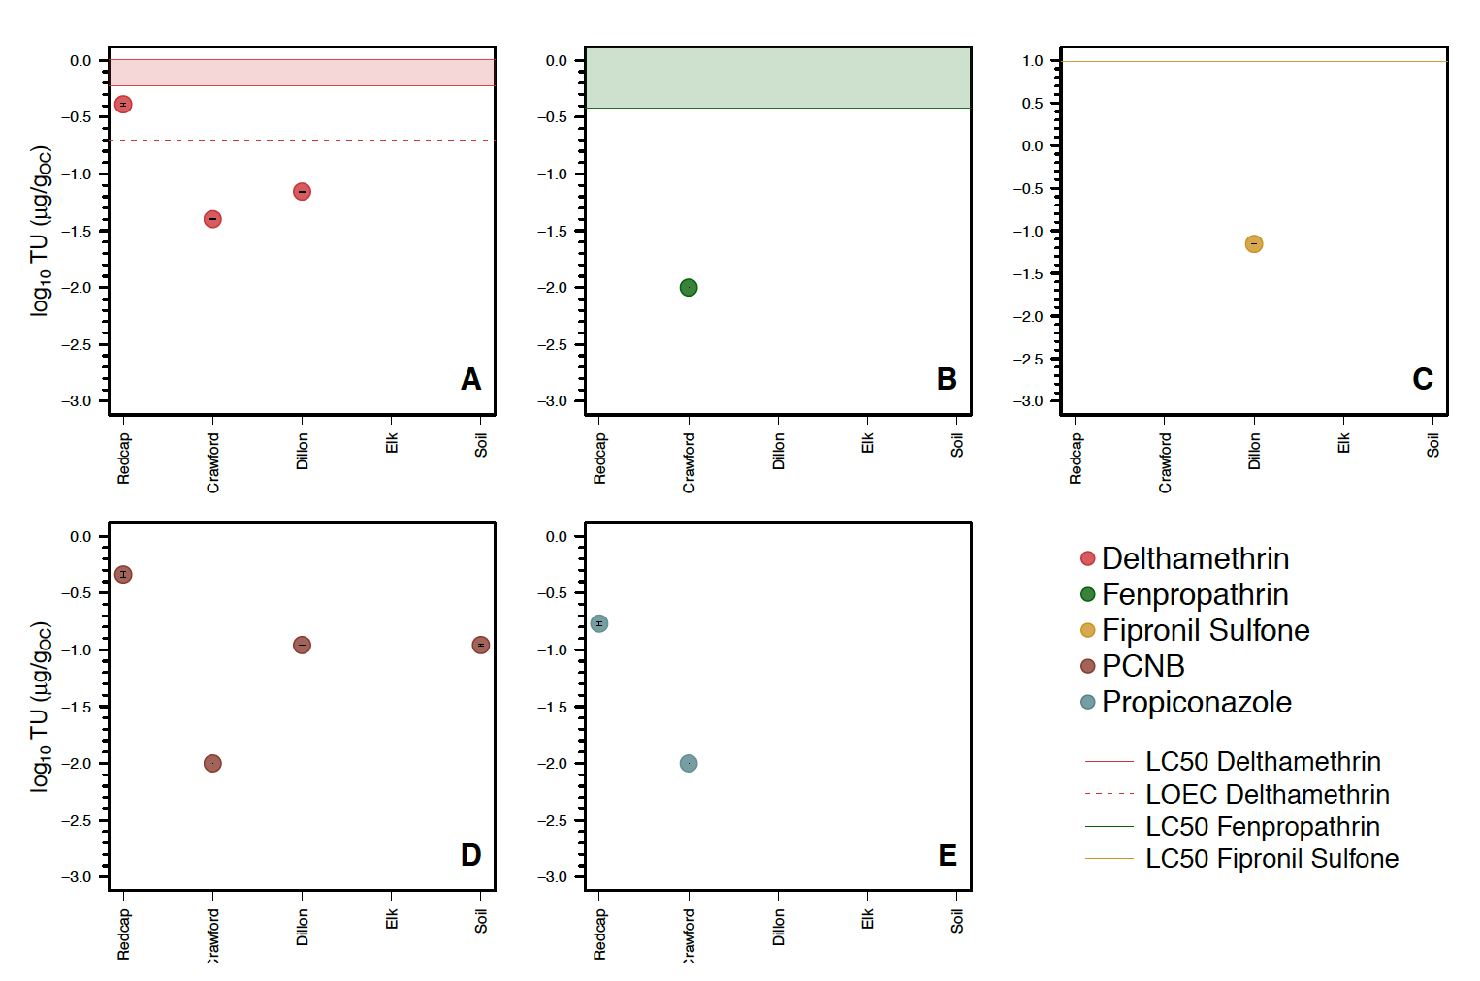

Establishing a baseline for pesticide loads
While it is difficult to pinpoint the source of these pollutants, this study finds that several pesticide contaminants linked to agricultural uses are present within mid-Klamath watersheds, including key water sources used by Karuk tribal members. At the same time, the compounds detected represent a small fraction of the pesticides that were tested for, and sediment concentrations were generally low when compared to toxicity levels. Findings suggest the importance of additional testing for a wider range of pesticides, more monitoring over different times and flow conditions, and the importance of establishing a meaningful baseline for pesticide loads in Karuk waters, before additional changes to land use and water quality occur.
Another potential set of target compounds to include in future monitoring campaigns are those compounds derived from the cannabis plant itself (Cannabis sativa L.). Due to the vast number of compounds contained within the plant, cannabis has a very complex chemistry, and there are possible interaction effects between plant compounds. One study analyzing natural compounds within C. sativa L. described a total number of 435, where 70 of these were cannabinoids [23]. There is currently a lack of experimental information about the toxicity of cannabinoids. However, based on theoretical models, LC50 concentrations (in ppm) for several cannabinoid compounds have been reported for fish, daphnia, and green algae in the ranges of 0.003-9.1, 0.002-16.9, and 0.0004-0.71 ppm, respectively [24].

Policy implications: expanding the array of pesticides being investigated and regulated
California regulations currently list only 66 active ingredients that should be tested for in cannabis products [25]. These are divided in two categories. Category I (N=21) involves pesticides banned for use on cannabis because they are not registered for use on food crops or are known to pose a risk to groundwater. Category II (N=45) is divided depending on whether the intended use is for ingestible or inhalable products. For this second category, cannabis products can be sold, as long as the pesticide levels in the finished product are below prescribed limits [26]. From the results of this study, only three of the pesticides found were listed in this regulation (i.e., fipronil, PCNB, and propiconazole), and the majority of pesticide compounds detected were not listed.
At the same time, other publications have developed more extensive lists of pesticides recommended for testing with cannabis products. For instance, Voelker and Holmes (2015) from the Cannabis Safety institute have created a list of 123 active ingredients to be monitored. This list includes (1) compounds that are likely to be used based upon discussions with growers or in cannabis blogs, and (2) compounds of concern for their toxicity, or compounds that have been identified as bad actors by PAN [20]. Another relevant list has been published by the Government of Canada [14]. The list contains 96 active ingredients for mandatory testing with cannabis products. Five of the active ingredients detected in our study from both water and sediment samples are included in this second list (i.e., deltamethrin, fipronil, fenpropathrin, PCBN and propiconazole).
It should be noted that in addition to agricultural uses, deltamethrin and fipronil can also be used in non-agricultural settings; therefore, we cannot confirm that the compounds were emitted solely for agricultural practices. Additionally, the most of compounds listed in the Category II from the CDPR regulation are substantially used in agriculture [27]. These outcomes show the complexity of efforts to identify sources of contamination due to cannabis cultivation.
Given the uncertainty about pesticide sources, field experiments that test for a wide range of pesticides could help support policy efforts to create effective environmental regulations for legal cannabis operations, and could potentially help facilitate clean up of contaminated areas around illegal cannabis grow sites.

Needs for future research
As we complete this report, the Karuk Department of Natural Resources is conducting a second sampling event corresponding to the first flushing flow events in the early winter of 2019-2020 (December-January). Occurring after the cannabis growing season, and associated pesticide applications, this campaign will provide additional baseline information on pesticide loading in mid-Klamath tributaries and water supplies.

Additional monitoring and research needs
- Assessing context-based sampling needs in rural areas such as the Klamath, and how to engage and coordinate local monitoring efforts.
- Developing monitoring schedules that are timed with local precipitation events and potential pesticide releases from associated runoff to tributaries.
- Developing monitoring schedules that account for the timing of the cannabis growing season and cultivation events, especially pesticide applications.
- Identifying tributary sampling locations with adequate sediment and organic matter deposition to facilitate effective monitoring.
- Identifying opportunities for increasing coordination with federal agencies, state agencies, and other tribes.
- Obtaining necessary locational information for known cannabis growing sites to anticipate and monitor downstream areas, including potential contamination hot spots.
- Additional testing of specific compounds associated with cannabis cultivation in the Klamath River Basin, e.g. anticoagulant rodenticides have been found in non-target wildlife such as bear, Mountain lion, Pacific fisher, squirrel, deer, and Northern Spotted owl on public and tribal lands.
- Additional development of inexpensive and low-tech passive samplers, especially samplers using thinner polymers, for this research context.
- Refining lab technology to test for plant derivatives (e.g., cannabis natural toxins) and identify substances of concern e.g., non-target analysis of compounds in the different samples.

References Cited
1. S. Diver, L. Liu, N. Canchela, R. Siberblatt, S.R. Tannenbaum, and R. Reed, Karuk Lands Management Historical Timeline. Web published at https://karuktimeline.wordpress.com/. Previously exhibited at the Karuk People's Center (Happy Camp, CA) and Clark Museum of Anthropology (Eureka, CA). 2010.
2. Cannabis Removal on Public Lands Project (CROP Project). Available at https://www.cropproject.org/. Last viewed December 26, 2019.
3. CDPR, Northwestern California Tribal Territories Herbicide Monitoring Project. California Department of Pesticide Regulation (https://www.cdpr.ca.gov/index.htm), Accessed on March 2019.
4. P. Wofford, K. Goh, D. Jones, H. Casjens, H. Feng, J. Hsu, D. Tran, J. Medina, and J. White, Forest Herbicide Residues in Surface Water and Planrs in the Tribal Territory of the Lower Klamath River Watershed of California. California Environmental Protection Agency. Environmental Monitoring Branch. Department of Pesticide Regulation. EH02-05, 2003.
5. D. Jones, N. Singhasemanon, D. Tran, J. Hsu, J. Hernandez, and H. Feng, Surface Water Monitoring for Pesticides in the Hupa and Karuk Terrirories. Environmental Protection Agency. Department of Pesticide Regulation. Environmental Monitoring and Pest Management Branch. Environmental Hazards Assessment Program. EH 00-12, 2000.
6. K.M. Norgaard, The Politics of Invasive Weed Management: Gender, Race, and Risk Perception in Rural California*. Rural Sociology, 2007. 72: p. 450-477.
7. R.B. Norgaard, Integrating Economics and Pest Management, in Integrated Pest Management, J.L. Apple and R.F. Smith, Editors. 1976, Springer US: Boston, MA. p. 17-27.
8. C. Thompson, R. Sweitzer, M. Gabriel, K. Purcell, R. Barrett, and R. Poppenga, Impacts of Rodenticide and Insecticide Toxicants from Marijuana Cultivation Sites on Fisher Survival Rates in the Sierra National Forest, California. Conservation Letters, 2014. 7: p. 91-102.
9. V. Butsic and J.C. Brenner, Cannabis (Cannabis sativa or C. indica) agriculture and the environment: a systematic, spatially-explicit survey and potential impacts. Environmental Research Letters, 2016. 11: p. 044023.
10. A.J. Cordone and D.W. Keller, The influences of inorganic sediment on the aquatic life of streams. California Department of Fish and Game, Inland Fisheries Branch, 1961. 47: p. 189-223.
11. A. Van Scoy-DaSilva, A. Poulsen, and R. Tjeerdema, The Potential of POCIS and SPMD Passive Samplers to Measure Pesticides in California Surface Waters. Final Report Agreement No. 11-C0115. Department of Environmental Toxicology. University of California, Davis., 2013-2014.
12. M.L. Hladik, K.L. Smalling, and K.M. Kuivila, Methods of Analysis- Determination of Pyrethroid Insecticide in Water and Sediment using gas Chromatography/Mass Spectrometry. U.S. Geological Survey. Technical and Methods 5-C2, 2009: p. 1-17.
13. PAN, PAN International List of Highly Hazardous Pesticides. Pesticide Action Network. http://www.pan-germany.org/download/PAN_HHP_List_161212_F.pdf (accessed 6th November 2019), 2016.
14. (-), Mandatory cannabis testing for pesticide active ingredients. Government of Canada. Gouvenement du Canada. (https://www.canada.ca/en/public-health/services/publications/drugs-health-products/cannabis-testing-pesticide-list-limits.html), 2019: p. 1-6.
15. B.A. Roberts, Legalized Cannabis in Colorado Emergency Departments: A Cautionary Review of Negative Health and Safety Effects. The western journal of emergency medicine, 2019. 20: p. 557-572.
16. J. Xiong, X. Zhang, J. Huang, C. Chen, Z. Chen, L. Liu, G. Zhang, J. Yang, Z. Zhang, Z. Zhang, Z. Lin, N. Xiong, and T. Wang, Fenpropathrin, a Widely Used Pesticide, Causes Dopaminergic Degeneration. Molecular neurobiology, 2016. 53: p. 995-1008.
17. H.K. Al-Makkawy and M.D. Madbouly, Persistence and accumulation of some organic insecticides in Nile water and fish. Resources, Conservation and Recycling, 1999. 27: p. 105-115.
18. C.A. Eagles-Smith and B.L. Johnson, Contaminants in the Klamath Basin: Historical Patterns, Current Distribution, and Data Gap Identification. Administrative Report. U.S. Geological Survey. Forest and Rangeland Ecosystem Science Center, 2012: p. 1-92.
19. S. Schneider, R. Bebing, and C. Dauberschmidt, Detection of pesticides in seized illegal cannabis plants. Analytical Methods, 2014. 6: p. 515-520.
20. R. Voelker and M. Holmes, Pesticide Use on Cannabis. Cannabis Safety Institute, 2014.
21. E.L. Amweg, D.P. Weston, and N.M. Ureda, Use and toxicity of pyrethroid pesticides in the Central Valley, California, USA. Environmental Toxicology and Chemistry, 2005. 24: p. 966-972.
22. W. Lao, D. Tsukada, D.J. Greenstein, S.M. Bay, and K.A. Maruya, Analysis, occurrence, and toxic potential of pyrethroids, and fipronil in sediments from an urban estuary. Environmental Toxicology and Chemistry, 2010. 29: p. 843-851.
23. M.A. ElSohly and D. Slade, Chemical constituents of marijuana: The complex mixture of natural cannabinoids. Life Sciences, 2005. 78: p. 539-548.
24. B.F. Günthardt, J. Hollender, K. Hungerbühler, M. Scheringer, and T.D. Bucheli, Comprehensive Toxic Plants–Phytotoxins Database and Its Application in Assessing Aquatic Micropollution Potential. Journal of Agricultural and Food Chemistry, 2018. 66: p. 7577-7588.
25. Cannabis Regulations (Currently in Effect)- January 2019. https://bcc.ca.gov/law_regs/cannabis_order_of_adoption.pdf. (accessed 11th January 2020). Bureau of Cannabis Control, California, 2019.
26. DPR, Pesticide That Are Legal to Use on Cannabis https://www.cdpr.ca.gov/docs/cannabis/cannot_use_pesticide.pdf (accessed 5th December 2019), 2018.
27. N. Seltenrich, Into the Weeds: Regulating Pesticides in Cannabis. Environmental Health Perspectives, 2019. 124.

Appendix A:

Figure A-1: Water Quality Monitoring Sampling Sites Overview. The four green points represent the approximate location of the sampling site i.e., Elk Creek (24,610ha), Dillon Creek (19,977ha), Crawford Creek (677ha), and Red Cap Creek (16,361ha). 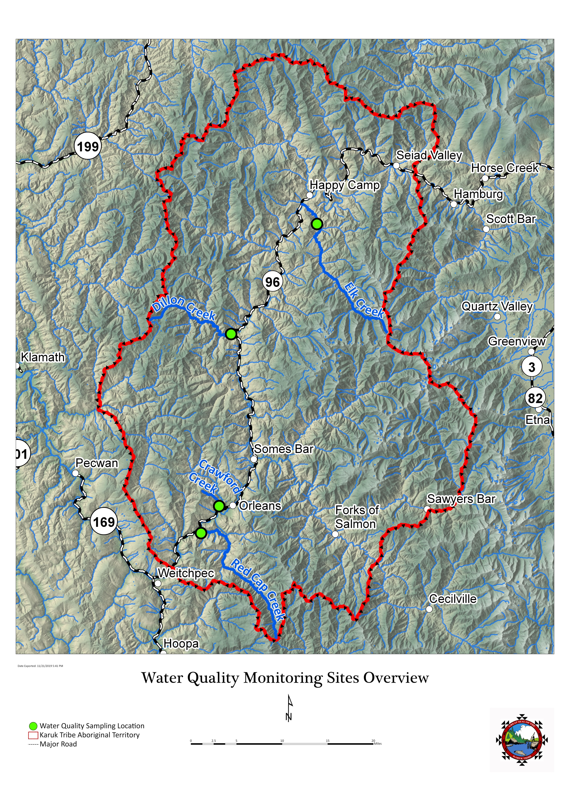

Figure A-2: Water Quality Monitoring Sampling Site Elk Creek
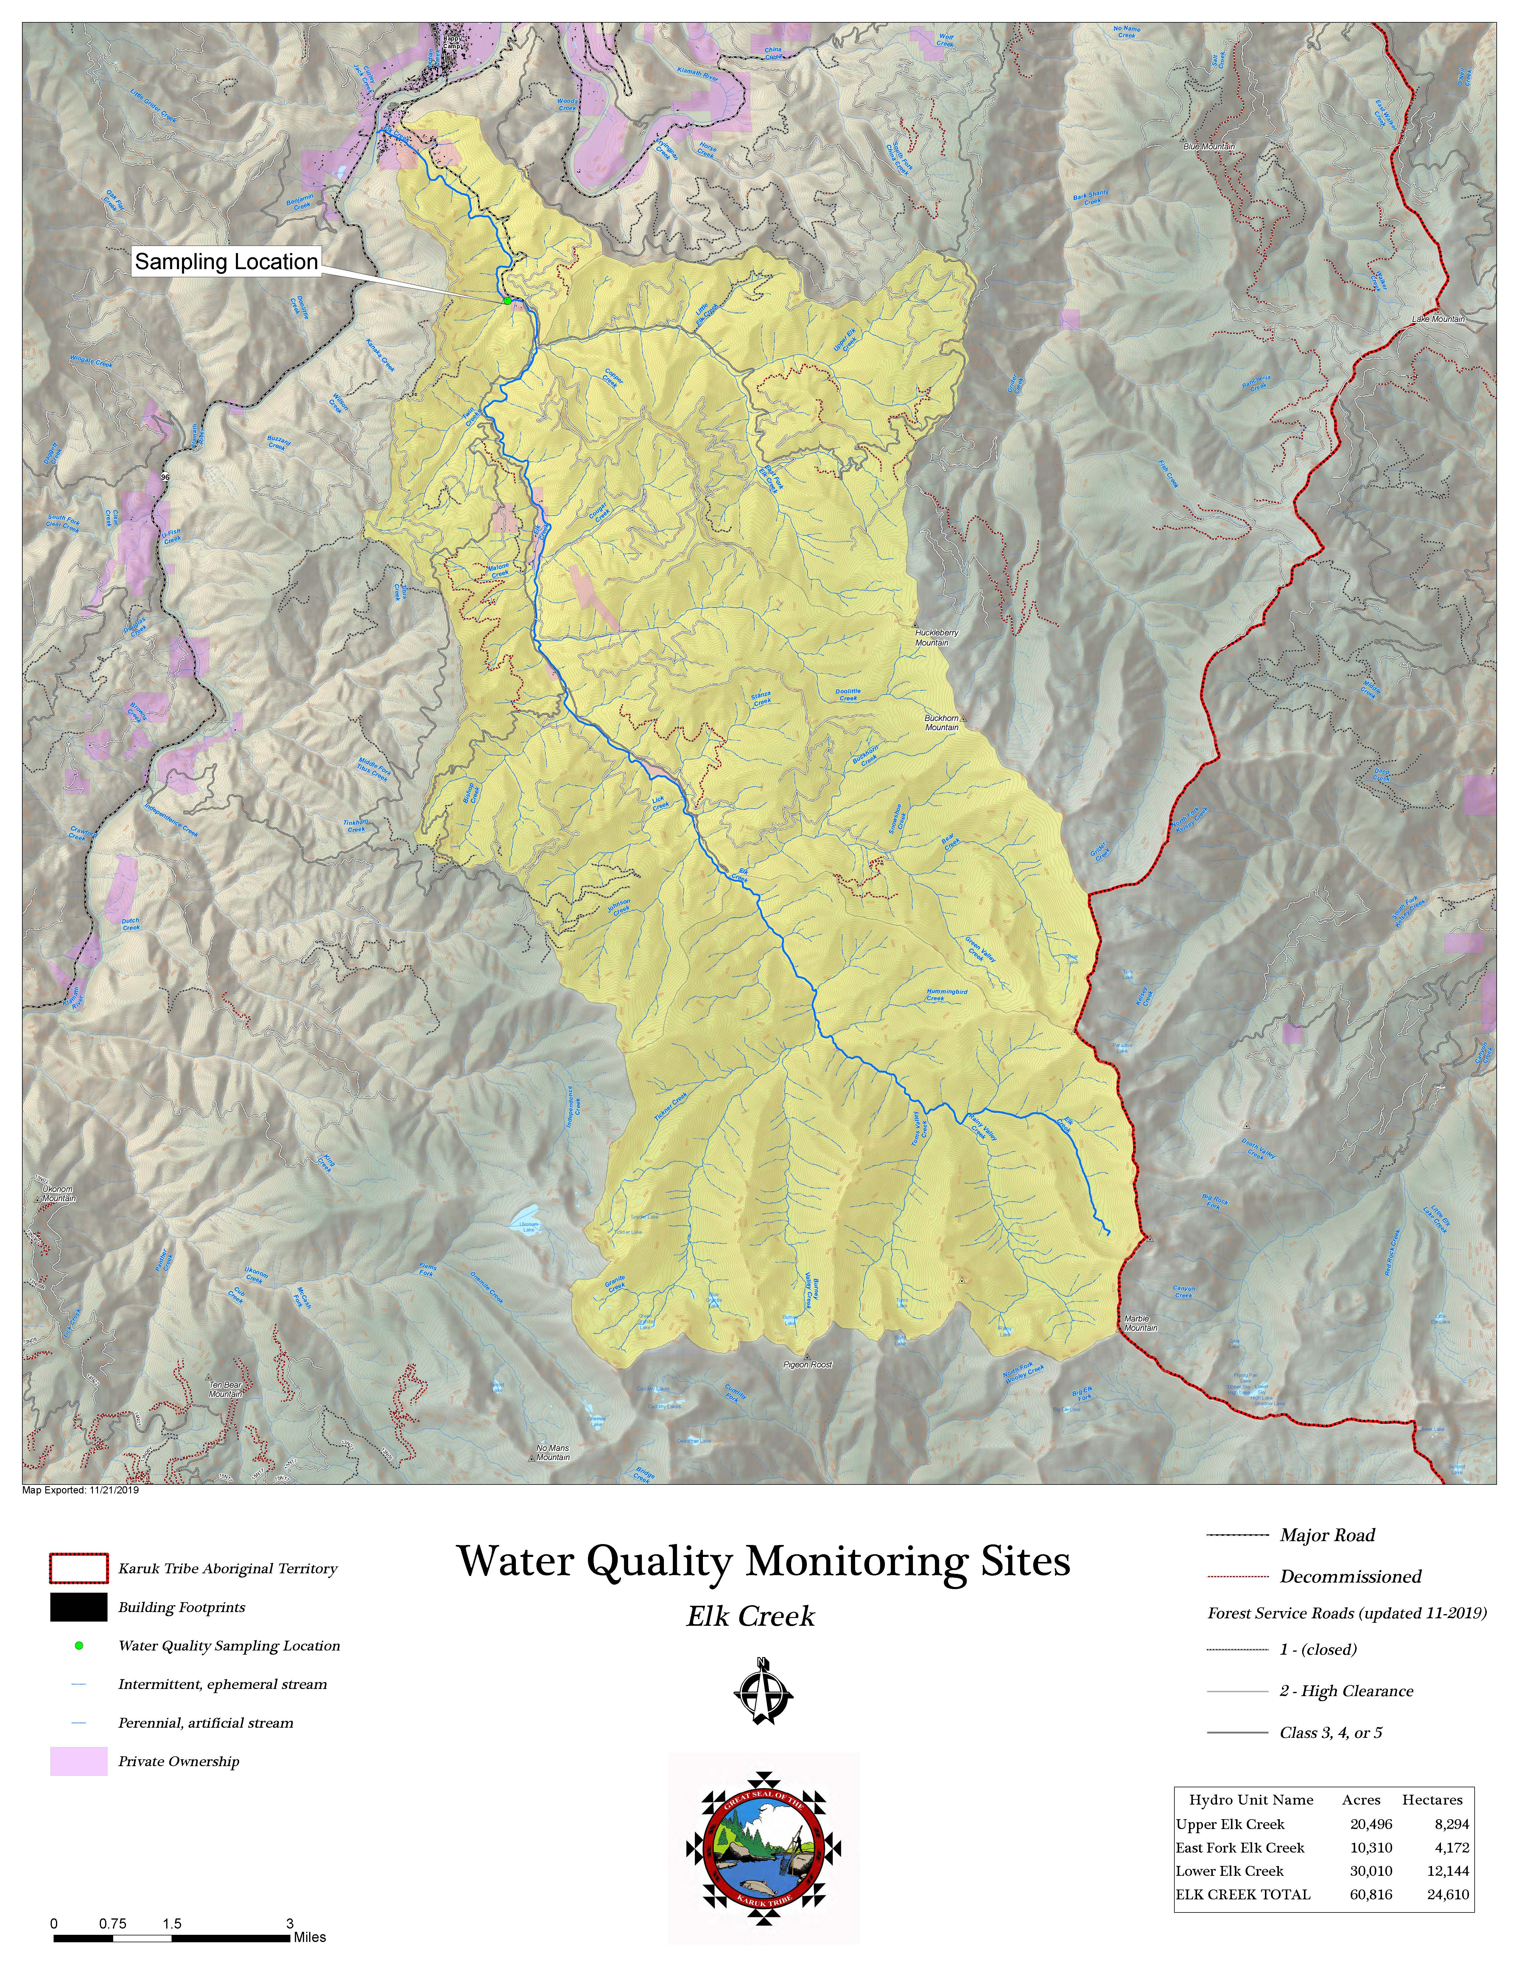

Figure 3: Water Quality Monitoring Sampling Site Dillon Creek
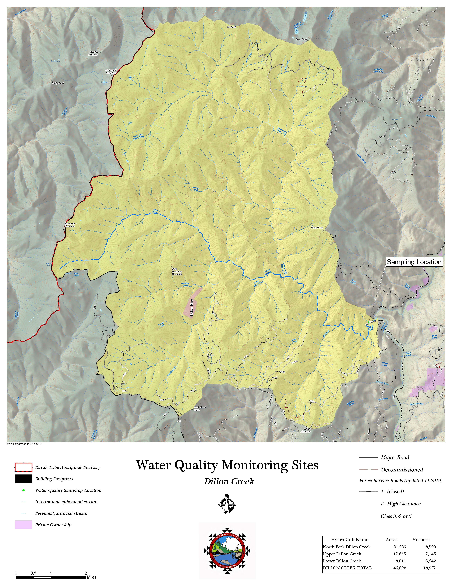

Figure 4: Water Quality Monitoring Sampling Site Crawford Creek
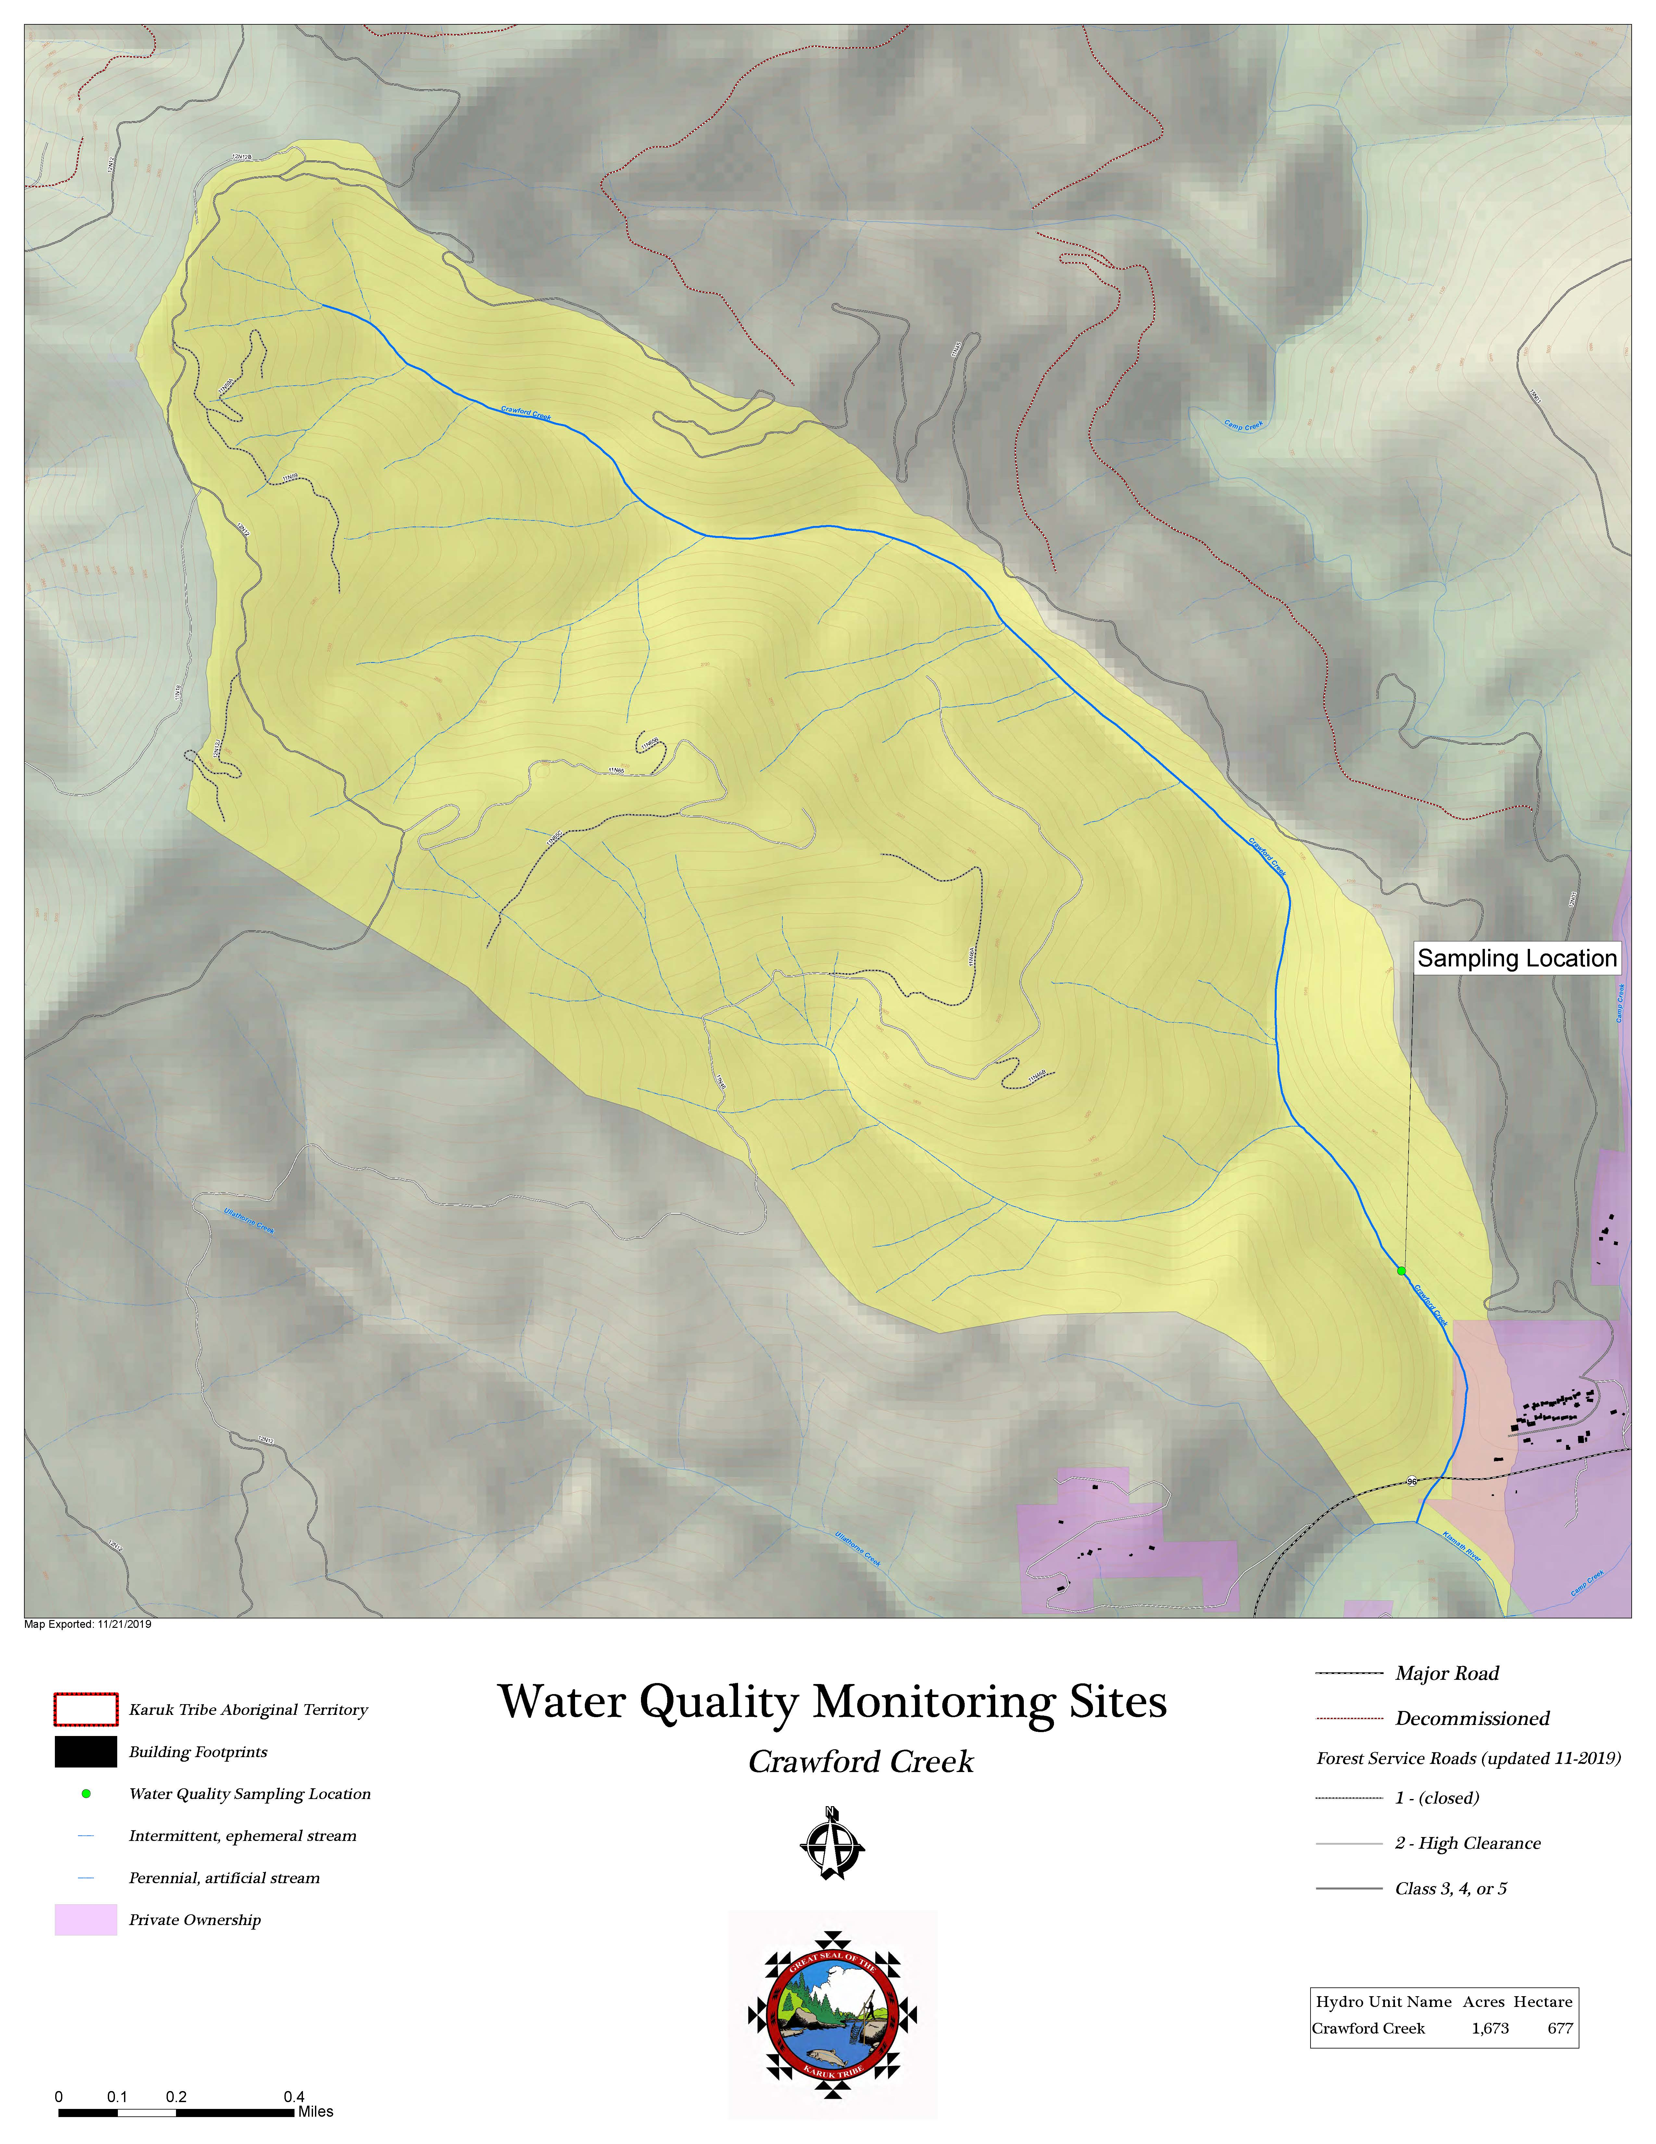

Figure 5: Water Quality Monitoring Sampling Site Red Cap Creek
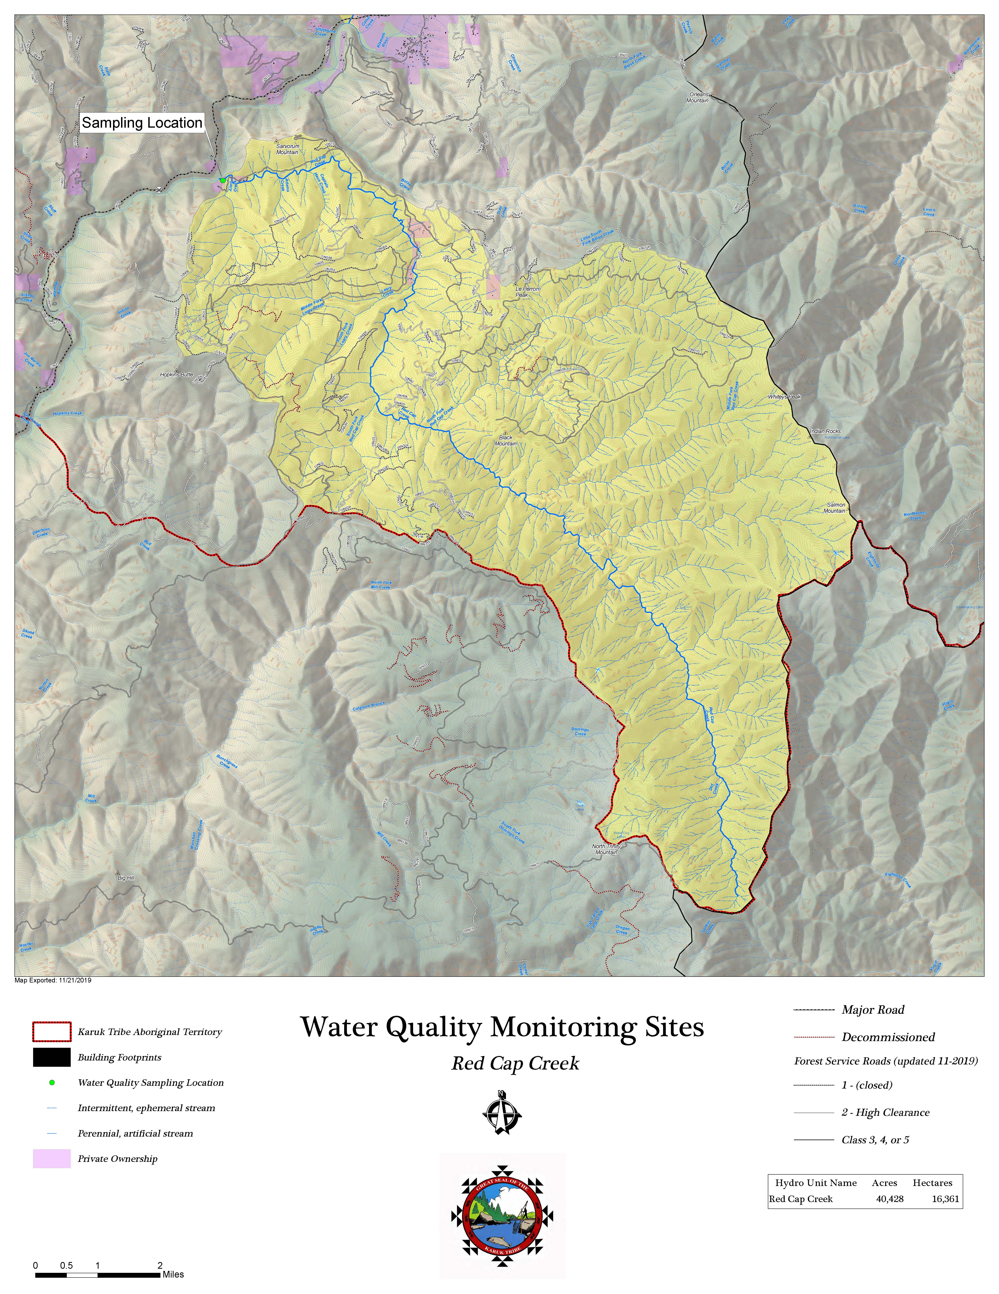

Appendix B: List of target compounds

Active Ingredient | CAS | Substance group | Pesticide type
3,5 dichloroaniline | 95-76-1 | Unclassified | Metabolite
5-OH Imidacloprid |  | Unclassified | Metabolite
6-Chloronicotinic Acid | 5326-23-8 | Unclassified | Metabolite
Acetamiprid | 135410-20-7 | Neonicotinoid | Insecticide
Acibenzolar-methyl | 135158-54-2 | Bemzothiadiazole | Fungicide, Insecticide, Plant activator
Allethrin | 584-79-2 | Pyrethroid | Insecticide, Veterinary substance
Atrazine | 1912-24-9 | Triazine | Herbicide
Atrazine, 2-Hydroxy | 2163-68-0 | Triazine | Metabolite
Atrazine, Desethyl | 6190-65-4 | Triazine | Metabolite
Atrazine, Desisopropyl |  | Triazine | Metabolite
Azoxystrobin | 131860-33-8 | Strobilurin | Fungicide
Benfluralin (Benefin) | 1861-40-1 | Dinitroaniline | Herbicide
Bentazon | 25057-89-0 | Benzothiazinone | Herbicide
Bicyclopyrone | 352010-68-5 | Triketone | Herbicide
Bifenthrin | 82657-04-3 | Pyrethroid | Insecticide, Acaricide
Boscalid | 188425-85-6 | Carboxamide | Fungicide
Boscalid Metabolite - M510F01 Acetyl |  | Unclassified | Metabolite
Bromuconazole | 116255-48-2 | Triazole | Fungicide
Butralin | 33629-47-9 | Dinitroaniline | Plant growth regulator, Herbicide
Captan | 133-06-2 | Phthalimide | Fungicide, Bactericide
Carbaryl | 63-25-2 | Carbamate | Insecticide, Plant growth regulator
Carbendazim | 10605-21-7 | Benzimidazole | Fungicide, Metabolite
Carbofuran | 1563-66-2 | Carbamate | Insecticide, Nematicide, Acaricide, Metabolite
Carboxin | 5234-68-4 | Oxathiin | Fungicide
Chlorantraniliprole | 500008-45-7 | Anthranilic diamide | Insecticide
Chlorfenapyr | 122453-73-0 | Pyrrole | Insecticide, Acaricide, Miticide
Chlorothalonil | 1897-45-6 | Chloronitrile | Fungicide
Chlorpyrifos | 2921-88-2 | Organophosphate | Insecticide
Chlorpyrifos Oxon |  | Organophosphate | Metabolite
Clomazone | 81777-89-1 | Isoxazolidinone | Herbicide
Clothianidin | 210880-92-5 | Neonicotinoid | Insecticide, Metabolite
Clothianidin des methyl |  | Neonicotinoid | Metabolite
Coumaphos | 56-72-4 | Organophosphate | Antiparasitic, Insecticide, Acaricide, Anthelmintic, Ectoparasiticide (Veterinary substance)
Cyantraniliprole | 736994-63-1 | Diamide | Insecticide
Cyazofamid | 120116-88-3 | Cyanoimidazole | Fungicide
Cycloate | 1134-23-2 | Triocarbamate | Herbicide
Cyfluthrin | 68359-37-5 | Pyrethroid | Insecticide
Cyhalofop-butyl | 122008-85-9 | Aryloxyphenoxypropionate | Herbicide
Cyhalothrin | 68085-85-8 | Pyrethroid | Insecticide, Veterinary substance
Cymoxanil | 57966-95-7 | Cyanoacetamide oxime | fungicide
Cypermethrin | 52315-07-8 | Pyrethroid | Insecticide, Veterinary substance
Cyproconazole | 94361-06-5 | Triazole | Fungicide
Cyprodinil | 121552-61-2 | Anilinopyrimidine | Fungicide
DCPA | 709-98-8 | Anilide | Herbicide
DCPMU | 3567-62-2 | Unclassified | Metabolite
DCPU | 2327-02-8 | Unclassified | Metabolite
Deltamethrin | 52918-63-5 | Pyrethroid | Insecticide, Metabolite, Veterinary substance
Desthioprothioconazole |  | Unclassified | Metabolite
Diazinon | 333-41-5 | Organophosphate | Insecticide, Acaricide, Repellent, Veterinary subtance
Diazinon Oxon |  | Unclassified | Metabolite
Dichlorvos | 62-73-7 | Organophosphate | Insecticide, Acaricide, Metabolite
Difenoconazole | 119446-68-3 | Triazole | Fungicide
Dimethomorph | 110488-70-5 | Morpholine | Fungicide
Dinotefuran | 165252-70-0 | Neonicotinoid | Insecticide
Dithiopyr | 97886-45-8 | Pyridine compound | Herbicide
Diuron | 330-54-1 | Phenylamide | Herbicide
S-Ethyl dipropylthiocarbamate | 759-94-4 | Thiocarbamate | Herbicide
Esfenvalerate | 66230-04-4 | Pyrethroid | Insecticide
Ethaboxam | 162650-77-3 | Thiazole | Fungicide
Ethalfluralin | 55283-68-6 | Dinitroaniline | Herbicide
Etofenprox | 80844-07-1 | Pyrethroid | Insecticide
Etoxazole | 153233-91-1 | Diphenyl oxazoline | Acaricide
Femoxadone | 131807-57-3 | Oxazole | Fungicide
Fenamidone | 161326-34-7 | Imidazole | Fungicide
Fenarimol | 60168-88-9 | Pyrimidine | Fungicide
Fenbuconazole | 114369-43-6 | Triazole | Fungicide
Fenhexamid | 126833-17-8 | Hydroxyanilide | Fungicide
Fenpropathrin | 39515-41-8 | Pyrethroid | Insecticide, Acaricide
Fenpyroximate | 134098-61-6 | Pyrazolium | Acaricide, Insecticide
Fipronil | 120068-37-3 | Phenylpyrazole | Insecticide, Veterinary substance
Fipronil desulfinyl |  | Unclassified | Metabolite
Fipronil desulfinyl amide |  | Unclassified | Metabolite
Fipronil sulfide |  | Unclassified | Metabolite
Fipronil sulfone |  | Unclassified | Metabolite
Flonicamid | 158062-67-0 | Pyridine compound | Insecticide, Aphicide
Fluazinam | 79622-59-6 | Phenylpyridinamine | Fungicide, Acaricide
Fludioxinil | 131341-86-1 | Phenylpyrrole | Fungicide
Fluensulfone | 318290-98-1 | Heterocyclic fluoroalkenyl sulfone | Nematicide
Flufenacet | 142459-58-3 | Oxyacetamide | Herbicide
Flumetralin | 62924-70-3 | Unclassified | Plant growth regulator
Fluopicolide | 239110-15-7 | Benzamide | Fungicide
Fluopyram | 658066-35-4 | Benzamide, pyramide | Fungicide, Nematicide
Fluoxastrobin | 361377-29-9 | Strobilurin | Fungicide
Flupyradifurone | 951659-40-8 | Butenolide | Insecticide
Fluridone | 59756-60-4 | Unclassified | Herbicide
Fluroxypyr | 69377-81-7 | Pyridine compound | Herbicide
Flusilazole | 59756-60-4 | Unclassified | Herbicide
Flutolanil | 66332-96-5 | Oxathiin | fungicide
Flutriafol | 76674-21-0 | Triazole | fungicide
Fluxapyroxad | 907204-31-3 | Pyrazolium | fungicide
Hexazinone | 51235-04-2 | Triazinone | Herbicide
Imazalil | 35554-44-0 | Imidazole | Fungicide, Veterinary substance
Imazapyr | 81334-34-1 | Imidazolinone | Herbicide
Imazethapyr | 81335-77-5 | Imidazolinone | Herbicide
Imidacloprid | 138261-41-3 | Neonicotinoid | Insecticide, Veterinary substance
Imidacloprid Desnitro |  | Unclassified | Metabolite
Imidacloprid Olefin |  | Unclassified | Metabolite
Imidacloprid Urea |  | Unclassified | Metabolite
Indaziflam | 950782-86-2 | Fluoroalkyltriazine | Herbicide
Indoxacarb | 173584-44-6 | Oxadiazine | Insecticide
Ipconazole | 125225-28-7 | Triazole | Fungicide
Iprodione | 36734-19-7 | Dicarboximide | Fungicide
Kresoxim-Methyl | 143390-89-0 | Strobilurin | Fungicide, Bactericide
Malathion | 121-75-5 | Organophosphate | Insecticide, Acaricide, Veterinary substance
Malathion Oxon |  | Unclassified | Metabolite
Mandipropamid | 374726-62-2 | Mandelamide | Fungicide
Mesotrione | 104206-82-8 | Triketone | Herbicide
Metalaxyl | 57837-19-1 | Phenylamide | Fungicide
Metalaxyl Alanine |  | Unclassified | Metabolite
Metconazole | 125116-23-6 | Triazole | Fungicide
Methamidophos | 10265-92-6 | Organophosphate | Insecticide, Acaricide, Metabolite
Methoprene | 65733-16-6 | Unclassified | Insecticide; Veterinary substance
Methoxyfenozide | 161050-58-4 | Diacylhydrazine | Insecticide
Methyl parathion | 298-00-0 | Organophosphate | Insecticide
Metolachlor | 51218-45-2 | Chloroacetamide | Herbicide
Molinate | 2212-67-1 | Thiocarbamate | Herbicide
Myclobutanil | 88671-89-0 | Triazole | Fungicide
Napropamide | 15299-99-7 | Alkanamide | Herbicide
Novaluron | 116714-46-6 | Benzoylurea | Insecticide; Insect growth regulator
Oryzalin | 19044-88-3 | Dinitroaniline | Herbicide
Oxathiapiprolin | 1003318-67-9 | Piperidinyl thiazole isoxazoline | Fungicide
Oxydiazon | 19666-30-9 | Oxidiazole | Herbicide
Oxyfluorfen | 42874-03-3 | Diphenyl ether | Herbicide
p,p'-DDD | 72-54-8 | Organochlorine | Insecticide, Metabolite
p,p'-DDE | 72-55-9 | Organochlorine
p,p'-DDT | 50-29-3 | Organochlorine | Insecticide
Paclobutrazol | 76738-62-0 | Triazole | Plant growth regulator; Fungicide
Pendimethalin | 40487-42-1 | Dinitroaniline | Herbicide
Penoxsulam | 219714-96-2 | Triazopyrimidine | Herbicide
Pentachloroanisole |  | Unclassified | Metabolite
Pentachloronitrobenzene | 82-68-8 | Chlorophenyl | Fungicide
Penthiopyrad | 183675-82-3 | Carboxamide | Fungicide
Permethrin | 52645-53-1 | Pyrethroid | Insecticide, Veterinary substance
Phenothrin | 26002-80-2 | Pyrethroid | Insecticide, Veterinary substance
Phosmet | 732-11-6 | Organophosphate | Insecticide, Acaricide, Veterinary substance
Picoxystrobin | 117428-22-5 | Strobilurin type- methoxyacrylate | Fungicide
Piperonyl butoxide | 51-03-6 | Performance enhancer, Synergist | Other substance, Veterinary substance
Prodiamine | 29091-21-2 | Dinitroaniline | Herbicide
Prometon | 1610-18-0 | Methoxytriazine | Herbicide
Prometryn | 7287-19-6 | Triazine | Herbicide
Propanil | 709-98-8 | Anilide | Herbicide
Propargite | 2312-35-8 | Sulphite ester | Acaricide
Propiconazole | 60207-90-1 | Triazole | Fungicide
Propyzamide | 23950-58-5 | Benzamide | Herbicide
Pyraclostrobin | 175013-18-0 | Strobilurin | Fungicide
Pyridaben | 96489-71-3 | Pyridazinone | Insecticide, Acaricide
Pyrimethanil | 53112-28-0 | Anilinopyrimidine | Fungicide
Pyriproxyfen | 95737-68-1 | Unclassified | Insecticide, Veterinary substance
Quinclorac | 84087-01-4 | Quinolinecarboxylic acid | Herbicida
Quinoxyfen | 124495-18-7 | Quinoline | Fungicide
Resmethrin | 10453-86-8 | Pyrethroid | Insecticide
Sedaxane | 874967-67-6 | Pyrazole | Fungicide
Simazine | 122-34-9 | Triazine | Herbicide
Sulfometuron Methyl | 74222-97-2 | Sulfonylurea | Herbicida
Sulfoxaflor | 946578-00-3 | Sulfoximine | Insecticide
tau-Fluvalinate | 102851-06-9 | Synthetic pyrethroid | Insecticide, Acaricide, Veterinary substance
Tebuconazole | 107534-96-3 | Triazole | Fungicide, Plant growth regulator
Tebuconazole t-Butylhydroxy |  | Unclassified | Metabolite
Tebufenozide | 112410-23-8 | Diacylhydrazine | Insecticide
Tebupirimfos | 96182-53-5 | Organophosphate | Insecticide
Tebupirimfos oxon |  | Unclassified | Metabolite
Tefluthrin | 79538-32-2 | Pyrethroid | Insecticide
Tetraconazole | 112281-77-3 | Triazole | Fungicide
Tetramethrin | 7696-12-0 | Pyrethroid | Insecticide
Thiabendazole | 148-79-8 | Benzimidazole | Fungicide, Veterinary substance
Thiacloprid | 111988-49-9 | Neonicotinoid | Insecticide, Molluscicide
Thiamethoxam | 153719-23-4 | Neonicotinoid | Insecticide
Thiamethoxam Degradate (CGA-353042) |  | Unclassified | Metabolite
Thiamethoxam Degradate (CGA-355190) |  | Unclassified | Metabolite
Thiamethoxam Degradate (NOA-404617) |  | Unclassified | Metabolite
Thiobencarb | 28249-77-6 | Thiocarbamate | Herbicide
Tolfenpyrad | 129558-76-5 | Pyrazolium | Insecticide, Fungicide
Triadimefon | 43121-43-3 | Triazole | Fungicide, Metabolite
Triadimenol | 55219-65-3 | Triazole | Fungicide; Metabolite
Triallate | 2303-17-5 | Thiocarbamate | Herbicide
Tribufos | 78-48-8 | Organophosphate | Plant growth regulator, Herbicide
Tricyclazole | 41814-78-2 | Triazolobenzothiazole | Fungicide
Trifloxystrobin | 141517-21-7 | Strobilurin | Fungicide
Triflumazole | 99387-89-0 | Imidazole | Fungicide
Trifluralin | 1582-09-8 | Dinitroaniline | Herbicide
Triticonazole | 131983-72-7 | Triazole | Fungicide
Vinclozolin | 50471-44-8 | Oxazole | Fungicide
Zoxamide | 156052-68-5 | Benzamide | Fungicide

Suggested citation: Bartolome, N., Crosby, E., Diver, S., Fricke, S., Hladik, M, and Johnson, G. Karuk Tribe Watershed Research Collaboration: A Pilot Study to Understand the Pesticide Impacts from Cannabis Cultivation within Karuk Aboriginal Territory (Surface Water and Sediments). Technical Report Prepared for the Karuk Tribe, December 2019.
We gratefully acknowledge the lab space and technical assistance provided by Richard Luthy and his group, especially Yeo Myoung Cho, Stephanie Spahr, and Conrad Pritchard. We thank Larry Alameda with the Karuk Department of Natural Resources for his valuable contributions to fieldwork. We also thank tribal members and land owners who provided access to samplings sites. We recognize and appreciate our ability to conduct this study on the traditional territory of the Karuk Tribe, with support from the Karuk Department of Natural Resources.
Section 303(d) of the Clean Water Act enables states, territories and authorized tribes to work with the EPA to list impaired and threatened waters. These entities can then respond to pollution problems by establishing the maximum amount of a pollutant allowed in a waterbody, referred to as a Total Maximum Daily Loads (TMDLs). This measurement serves as the starting point or planning tool for restoring water quality.

